Camp I
With our encoding skills at an elite level, we'll increase our lower-order memorisation skills for when there is no alternative.
Overview and recommendations
Key dimensions | Retrieval, self-regulation
Recommended pace | Most learners see best results with 3 hours of theory across 1 to 2 weeks.
Recommended practice | Variable (see progression tips).
Progression tips | This stage focuses on lower-order memorisation needs. The amount of practice needed depends on your need for memorisation techniques. Most of these techniques do not require substantial practice. Feel free to progress at a comfortable pace.
How this stage helps you
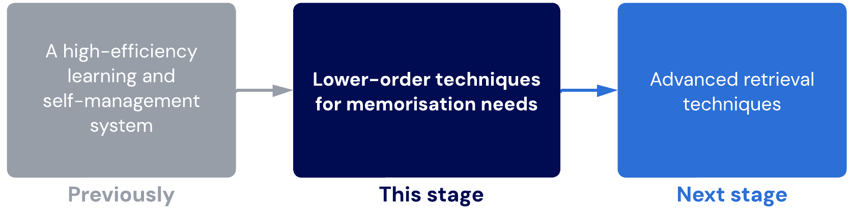
Lessons
- Rote learning and memorisation
An overview of Camp I and the techniques you will learn.
- Flashcards
Learn to use flashcards like a pro, while avoiding all the negative side effects.
Sublessons:
- Active flashcard management
- Revision
Touch up on some of the basic principles of revision and retrieval practice.
- Modified method of loci
Learn a powerful lower-order memorisation technique for remembering long lists of detailed information.
- Camp I check
Quickly check your general competence before moving to Camp II.

- Rote learning and memorisation
We will now learn how to memorise the outer layer of information (i.e., arbitrary information) using high-efficiency memorisation techniques.
Only use rote-learning techniques and memorisation as a last resort. These techniques only apply to the outer layer of information – focus on the three inner layers to maximise your conceptual understanding first!
New techniques
Technique | Rationale
Correct flashcard usage | Flashcards are effective when used well. Now that we’ve built a strong foundation with logical and relationship-priority learning, we can use rote-learning and memorisation techniques to fill the gaps.
Modified method of loci | This world-champion-level technique allows you to memorise hundreds of items in a single sitting.
Techniques to continue
Technique | Notes
Bear Hunter System with hipshot variation | Continue to improve your competency and optimise the Skin step. In this stage, we will see improvements in speed.
Scheduling basics + Priority 0+1 system | Continue to do this so it becomes habitual.
Revision | Continue with good revision practice. We will build on this in the next stage.
Focus training | It is critical that you continue to do this, as it will help you overcome the “activation energy” of change and create significant cognitive restructuring. In other words, it will turn you into a machine of pure, unwavering focus.
PEER-Peer System | Continue to develop new habits, lock in existing good habits, and remove distractions. This process should continue forever.
OFF-Rest timing | Continue to use this whenever you need to focus. This should continue forever.

- Flashcards
Overview of flashcards
A flashcard is a card that has a question or prompt on one side and an answer on the other. If you’re using an app, your flashcards may have more than two "sides". The prompt on a flashcard can commonly be:
- A question
- Fill in the blanks
- Image occlusion (i.e. fill in the blanks of an image)
Using flashcards as a learning strategy can be effective when executed correctly. Crucially, we want to avoid:
- Having too many flashcards: This creates overwhelm and requires a high regular and repeating time investment. Only layer 3 and 4 should be on flashcards.
- Testing on too many things in a single prompt: When we do this, it becomes difficult to decide whether we get a card "correct" or "incorrect" if there is a combination of correct and incorrect answers.

Flashcards vs. summary cards
Flashcards are different from summary cards. Flashcards test you on information, while summary cards are discrete cards that provide a summary of information. Unlike flashcards, summary cards do not produce a generative effect on learning.
Some people have hundreds or thousands of flashcards. This is inefficient and unsustainable. This can be reduced with proper layers of learning as more information becomes naturally relevant and deeply encoded.

Key benefits of flashcards
It allows spaced retrieval practice for lower-order information
It functions as a "second brain" reference source of information
It is easy to use
It enables microlearning

Microlearning
Flashcards are powerful because they allow you to engage in microlearning, or short bursts of studying (e.g., while taking the bus). Conceptual learning can’t usually be done in short bursts, making flashcards a great tool to fill in small gaps in your schedule.

Don’t use flashcards in long study sessions, as this doesn’t activate microlearning conditions and is thus less effective. Keep it to short bursts of 3 to 10 minutes per session.

Go Digital
Don’t use physical flashcards, which are harder to access for microlearning. Apps, like Anki, are much more accessible and effective, as they calculate the best time for you to review each flashcard based on spaced-repetition algorithms.

This level of flexibility, control and convenience is impossible with physical flashcards. The (extremely minor) benefit of writing flashcards by hand is insignificant compared to the benefits of going digital.

Related video
You might also be interested in this YouTube video on maximising your flashcards here.
https://www.youtube.com/watch?v=eauQac_23R0

Sublesson: Active flashcard management

General flashcard guidelines
- Use digital flashcards (e.g., Anki)
- Only use flashcards for layers three and four (the important and arbitrary details).
- Reduce your number of flashcards as much as possible. You shouldn’t need more than 50 flashcards for an entire topic. If there are more than 50, there may be a mistake in your conceptual learning.
- Each flashcard should have a targeted question and a discrete fact. Do not include more than two or three facts on a single flashcard.
- Even if you don’t know the answer to a flashcard, give it your best guess before checking the answer. It’s not about getting it right; it’s about generating an answer and correcting yourself to activate generation and hypercorrection effects.
Key principle
The generation effect is critical for effective learning. Generating an answer produces more learning than simply checking an answer. For example, reading the answers for a practice exam is less effective than taking the time to write real answers.
The hypercorrection effect is a perfect synergy. Making a mistake and being corrected produces a higher level of learning than getting it right the first time. The more confidence you had in your incorrect answer, the higher your level of learning will be.
Leitner system
The Leitner system is an implementation strategy of spaced repetition commonly adapted and utilised for flashcards and microlearning.
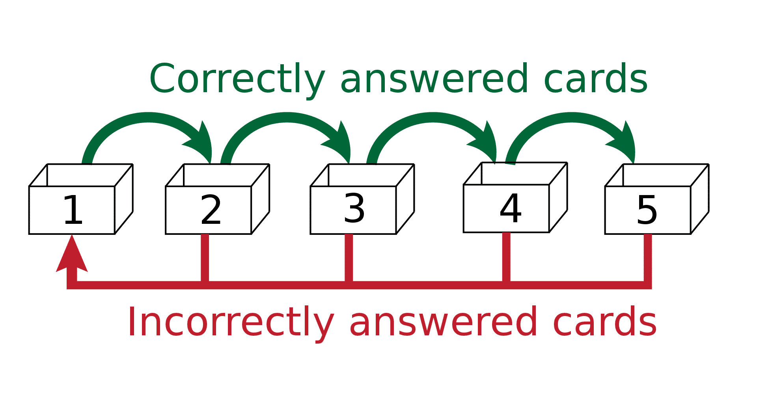Source: https://en.wikipedia.org/wiki/Leitner_system
As you can see from the diagram above, incorrect flashcards move backwards while correct cards move forwards.
If we track the movement of a single card, it might look like this:
- Answered correctly
- Moves to box 2, due for a repeat in 1 hour
- Answered correctly again
- Moves to box 3, due for a repeat in 4 hours
- Answered correctly again
- Moves to box 4, due for a repeat in 16 hours
- Answered incorrectly
- Moves back to box 3, due for a repeat in 4 hours
- Answered incorrectly
- Moves back to box 2, due for a repeat in 1 hour
One benefit of the Leitner system is that it prioritises weak areas.
However, a disadvantage is that cards can accumulate quickly if you get many incorrect. If you have lots of flashcards (e.g., 200+), it is difficult to get them all correct. As a result, earlier stage boxes start “overflowing”, making it hard to stay on top of your flashcards.
This is where our flashcard management guidelines come into play.
Rule of 3 method for managing flashcards
Instructions
- Combine
- Cut
- Critique
Expand the accordions below to learn more about each rule.
Combine
If you get a flashcard correct three times in a row:
Merge them with another conceptually related card that you also got correct three times to create a higher-order question.
For example, if one card asks about the definition and purpose of judicial law and another asks about the definition and purpose of parliamentary law, you could combine them to create a question like, "What are the key differences between the definitions and purposes of judicial law compared with parliamentary law?". A further combination could be even more higher-order, such as, "How important is judicial law compared to parliamentary law in heavily litigious industries?"
This way, we reduce the number of flashcards in the deck while testing ourselves at higher orders. When combining cards, ensure that you include the lower-order information from each card as a prerequisite knowledge to answer the new higher-order prompt. You wouldn't want to create a card on two conceptually related pieces, but ask a completely different angle that does not build on your existing knowledge. In the examples above, the knowledge of definitions and purpose is still tested, just at a higher order.

Cut
If you get a flashcard correct three times in a row (and there are no conceptually related cards to combine with):
Remove this card from your deck. This rule is flexible: if you are worried, leave the flashcard in the deck and let the spacing algorithm naturally extend the delay between attempts. However, if you feel cluttered with cards, these cards should be the first to be removed.
At the very least, change the wording on the card to prevent yourself from falling into a recognition trap where you are unable to recall the information without this highly specific cue.

Critique
If you get a flashcard incorrect three times (out of 5 attempts):
Go back to the material and learn more deeply about it. Go outside the scope of the curriculum, consider its applications, and try to create a more robust conceptual understanding. You must give the information more relevance to prevent yourself from repeatedly forgetting it.
These cards you get wrong consistently will take up more time because you never clear them from your deck. It is worthwhile to invest five to 10 minutes to consolidate more deeply instead of sticking with a lower-order approach, which has proved ineffective.

- Revision
The purpose of revision is to recall the information in your study material.
However, there are different ways to revise. Some people only practise recognising the information. Other people rely on cues to help them recall it.
It is better to have true recall, where you can remember and apply the information even without cues.
To help with your revision, we will go through techniques that build true recall.

- Modified method of loci
About the modified method of loci
The modified method of loci builds upon the original method of loci (more commonly known as the Memory Palace) to help you remember large strings of arbitrary information.
Instructions
- Create a story or "scene" with different elements for each piece of information.
- Make elements absurd. Mundane and boring elements are not memorable.
- Keep elements spatially distinct. Don't have too many things happening in the same "location".
- Make elements interdependent. Create relationships between elements to help with retention.
- Draw out your "scene" in your mindmap canvas to serve as a memory anchor. This replaces the normal "visualisations" you have been using.
Your drawing doesn’t have to look nice; it just needs to consolidate the information in your brain. Even students with zero artistic ability can successfully use this technique.
Usage notes for this technique
- As a lower-order memorisation method, it is not effective or efficient for information that has causal/functional/conceptual relationships with other pieces of information.
- This method excels with lists of information (ordered or unordered).
- It can be used for small lists of just a few items, or longer lists of 30+.
- This method should not replace higher-order encoding approaches if a higher-order relational network is viable.

- Camp I check

General competence assessment
As the techniques in this stage do not require much (if any) cognitive retraining, you should be able to progress through this stage relatively quickly. Use the table below to check your general competence level, and feel free to move onto Camp II as soon as you feel ready.
Technique(s) | Level of Competency
Flashcard usage | You can manage your flashcards actively, accurately and sustainably.  Your flashcards fill rote-learning gaps at layers 3 and 4 of learning.
Modified method of loci | You can seamlessly integrate these into GRINDE maps and mind maps while studying for layers 3 and 4 of learning.
Focus training and PEER-Peer system | These are a fixed part of your daily routine.  You may have also noticed some improvements in your natural ability to focus.

